Understanding Your Utility Bill

Your Utility Bill Plain City Utility Bill Explained
Water:
1 Water charge will be variable depending on gallons used each month.
 |  | 123 Name Street Plain City, OH 43064
WAT | 44186 | 45275 | 1089 | 16.60
SEW | 44186 | 45275 | 1089 | 18.43

Usage charge per month: $16.60 minimum charge up to 2,000 gallons used

1 000
5
10/15/2020

Sewer:
$ 5.19 per 1,000 gallons after the first 2,000 gallons

SUR TRA
2
6.50
3 18.49

4

66.02 60.02
6
Sewer charge will be variable depending on gallons used each month.
Usage charge per month: $18.43 minimum charge up to 2,000 gallons used
$ 8.50 per 1,000 gallons after the first 2,000 gallons
Trash:
Not variable - Same charge each month Usage charge per month: $18.49
Surcharge:
Not Variable - Charge is for a portion of the 2005 Wastewater Treatment Expansion project

1 000
08/17/2020 09/21/2020

10/15/2020 66.02 60.02
Usage charge per month: $ 6.50


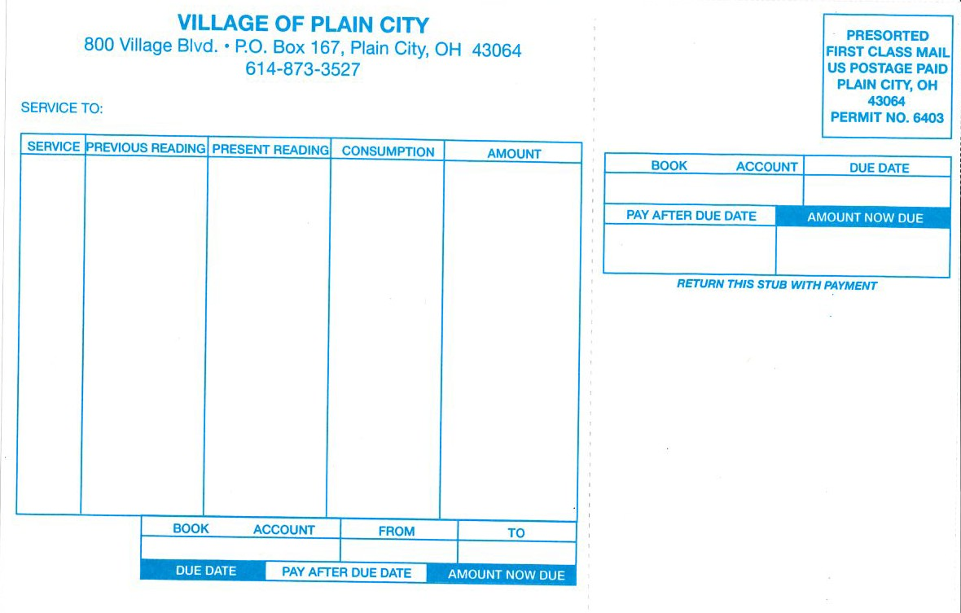



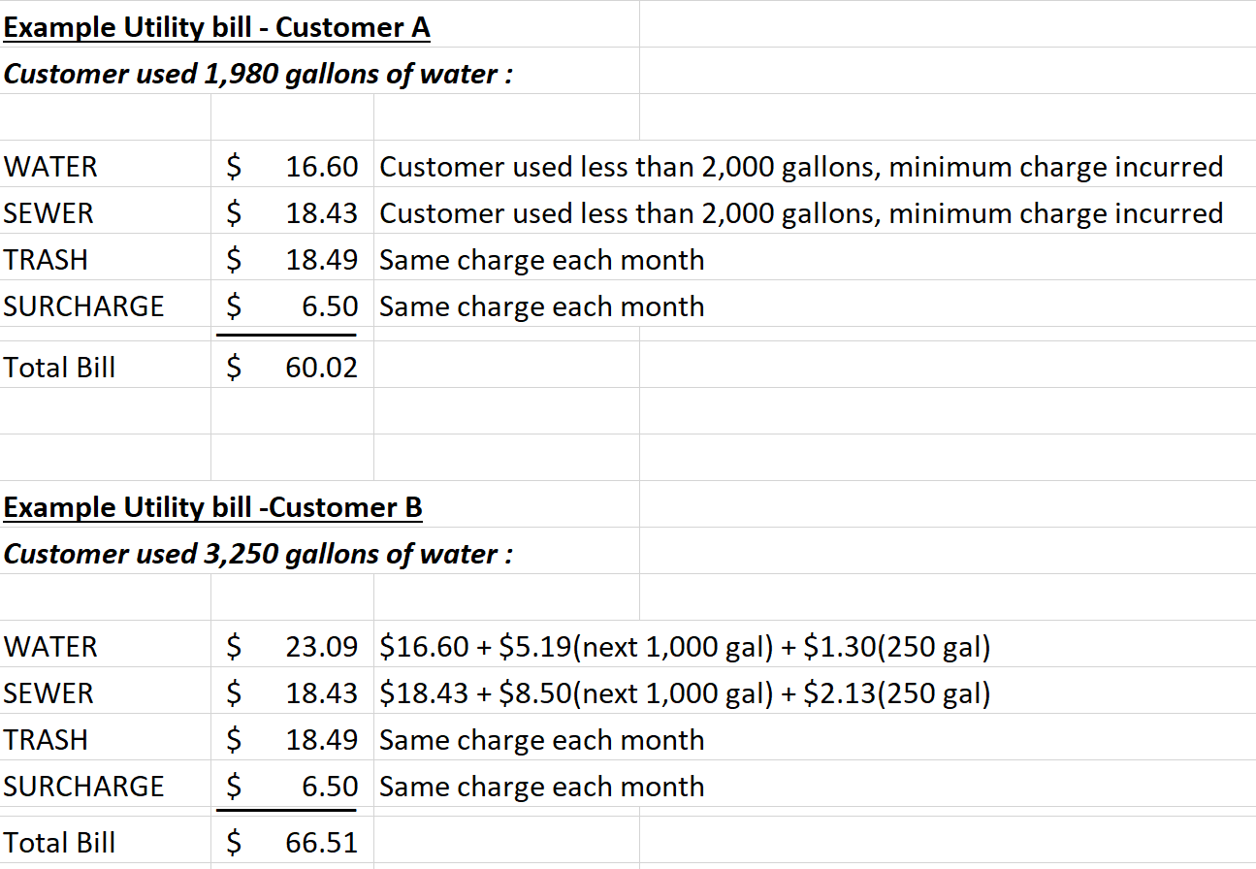

- Service To
This shows the address in which the service is issued to.
- Service
Within the Village of Plain City, four service charges are issued to the account holder on a monthly basis which include a service fee for water, sewer, trash and a surcharge.
- Consumption
Consumption rate is your usage for each service for the billing cycle. The amount is used to calculate your payment total for the billing cycle.
- Billing Cycle
The billing cycle is the date range in which the consumption rate falls between. Reading are conducted on the 3rd Monday of each month.
- Due Date
This is the date in which the payment is due. Please pay on time to avoid the 10% late fee penalty.
- Amount Due
The amount owed for the billing cycle. You can pay in person, online or via our 24 hour drop box available at the office. Cash, check or credit card are accepted.

Deduct Meter: An installed water metering device, customers can request from the Village, which measures the amount of water used in outdoor activities, such as irrigation and pool filling, that is not discharged into the sanitary sewer system. Water used for those activities does not incur a sewer charge, saving customers money through a sewer credit received twice a year.
If you have questions, please call the Village of Plain City at 614-873-3527, email village@plain-city.com, or visit www.plain-city.com

