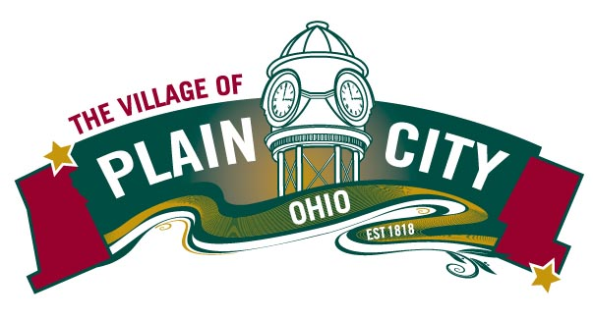
PARKS & RECREATION COMMITTEE AGENDA
November 8, 2022

COUNCIL MEETING

Committee Members: Eli Abrams, Justin Giaimo, Katie Khoury, Polly Seum, Kathryn Harriman
Chair: Eli Abrams Vice Chair: Polly Seum Council Liaison: Frank Reed
Parks & Recreation Director: Linda Granger Parks & Recreation Assistant: Denton Kitts

Call to Order

Approvals Minutes from October 11, 2022

Director’s Report
- Fall Fest
- Veterans Day Ceremony
- Christmas Under the Clock
- Camping software
- Recreation Planning 2023
- Volunteer program

Old Business
Parks & Rec Vision Plan & CIP

New Business

Adjourn

