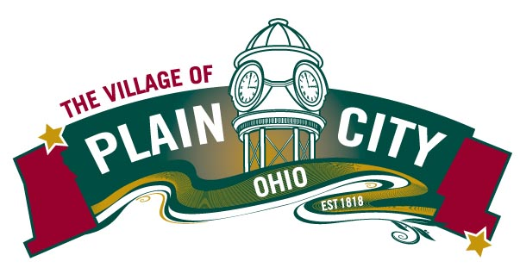
PARKS & RECREATION COMMITTEE AGENDA
October 12, 2021

COUNCIL MEETING

Committee Members: Eli Abrams, Justin Giaimo, Katie Khoury, Polly Seum, Kathryn Harriman
Chair: Eli Abrams Vice Chair: Polly Seum Council Liaison: Sherry Heineman
Parks Director: Linda Granger

Call to Order
Approvals
  - Minutes from September 14, 2021
Director’s Report
Events
- Fall Fest!
  - This Saturday, October 16th 5-8 pm (see printed flyers)
  - Plethora of things to do
  - Largest cost is Pumpkin Carver(400 lb pumpkin)

  - Christmas Under the Clock/Holiday season
    - Santa Mailbox returns, Lights at Park return
    - Focus on Uptown -Open Houses for businesses
    - Traditional Tree Lighting and coloring contest
    - Santa & Reindeer uptown then Santa tours neighborhoods
    - Twirlers, PC Singers & Bell Choir, and food trucks
Campground
Gross Revenue $274,462
Net Revenue after fees $257,815
Fees 6%

Old Business
- Speed bumps -Ordered
- Volunteer Program- Katie

New Business
- Campground Length of Stay limit

Adjourn

