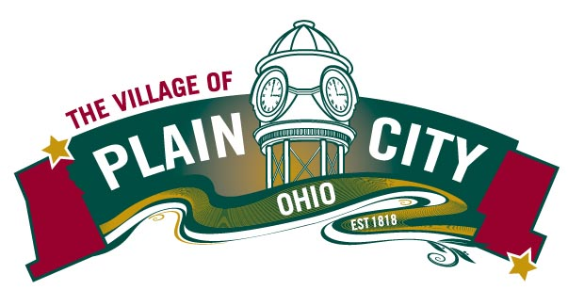
PARKS & RECREATION COMMITTEE AGENDA
April 13, 2021

COUNCIL MEETING

Committee Members: Eli Abrams, Justin Giaimo, Katie Khoury, Polly Seum, Kathryn Harriman
Chair: Eli Abrams Vice Chair: Polly Seum Council Liaison: Sherry Heineman
Parks Director: Linda Granger

Call to Order
Approvals
- Minutes: March 9, 2021
Director Report
- Campground revenue is incredibly strong
- Working on a Parks & Rec specific Newsletter this week. Focus on the pool, special events.
- New Rec Assistant hired. Started April 12. Will be focusing on adding special events and “Day of” mgt.
- Swim Team Update-Capped at 130 swimmers and swimmer roster is full.
- Spring Volleyball- only 2 team so far.
- Softball league- mid summer start date.
- Handwashing/drinking stations were installed.
- Pool on track to be painted & splash pad renovated by April 30.
- Discussed McKitrick trash can/clean up and water pooling under bridge with Public Works.

Old Business
- Park Volunteer Group- Katie Khoury
- ODNR Facility grants/Survey results
  - Haley Lupton – Mgt. Analyst
75% Funding with local 25% match
- Due June 1, 2021
- Funds allocated by County
- FY 2021: Madison $82,445 Union $82,206
Cost Grant Village
Madison Playground at Madison Meadows $150,000 $82,445 $67,555
Union Renovate Basketball Court $121,430 $82,206 $39,224

New Business
- Zoning Steering Committee- Participant Needed
The Village is under-going a re-write of our zoning code. The project goal is to, bring the code up to date, make the documents more user friendly, and incorporate relevant recommendations from the Comprehensive Plan.
The purpose of the steering committee is to gain perspective on what is working and not working about the code, share your ideas, and indicate where you would like to see improvement in how the code is affecting the community’s growth and development.
The committee would most likely meet 4-5 times over the course of the year.
Potential Kick-off Meeting Dates: April 29th 3-4pm or May 3rd after 5pm

Adjourn

