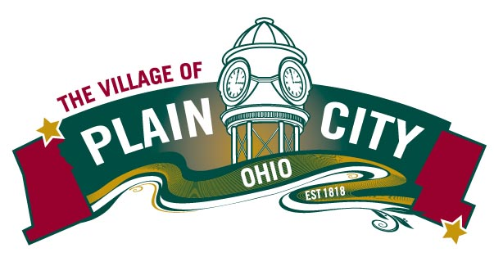
PARKS & RECREATION COMMITTEE AGENDA
August 15, 2022

COUNCIL MEETING

Committee Members: Eli Abrams, Justin Giaimo, Katie Khoury, Polly Seum, Kathryn Harriman
Chair: Eli Abrams Vice Chair: Polly Seum Council Liaison: Frank Reed
Parks & Recreation Director: Linda Granger

Call to Order

Approvals Minutes from July 12, 2022

Director’s Report
- Reminder- Committee is invited to Council Work Session- Sept. 7 @ 6:30pm
- Searching for new fireworks provider
- Working on obtaining new Campground management software provider
- Possible Tree Grant opportunity- Due 10/14. Possible reinstatement of Tree Commission
- Working on Heritage Trail – partners & funding
- Beginning to work on Fall Fest and Christmas Under the Clock
- Pool- drainage issues- may need concrete added- After pool closes into 2023
- Farmers Market- Doing well under Denton’s management
- Steam Thresher event- Clean up was very slow.

Old Business
- CIP Plan- Additional Discussion- plus Council request for planning

New Business

Adjourn

